Corporate Ticketing System & Health Issue Classification

Name: Vishnu V
Roll Number: 71762234060
Course: 19MAME23

Executive Summary
This case study examines the application of Large Language Models (LLMs) to solve the challenge of identifying and routing health-related tickets in a corporate ticketing system. With the advent of medical counsel and hospital partnerships, organizations must now automatically classify tickets without historical labeled data. This document presents an analysis of the text classification problem, challenges with unlabeled data, the role of LLMs, and a proposed solution design using zero-shot and few-shot learning with prompt engineering.

1. Text Classification Problem Identification

1.1 Why This is a Text Classification Problem
Identifying health-related tickets is fundamentally a text classification problem in NLP for the following reasons:
a) Unstructured Textual Input: Employee tickets are submitted as free-form text descriptions that must be analyzed to extract meaning and intent.
b) Categorical Output Requirement: The system must assign each ticket to predefined categories (health-related vs. non-health-related), which is the fundamental definition of classification.
c) Semantic Understanding Required: The classification task requires understanding context to differentiate between medical symptoms, technical issues, and administrative requests.
d) Natural Language Variability: The system must handle synonyms, medical terminology vs. layman’s terms, and implicit health mentions.
e) Multi-Class Decision Making: Beyond binary classification, the system may route tickets to sub-categories like emergency medical, mental health, or injury reports.

1.2 Input, Output, and Classes
INPUT:
- Unstructured text (free-form employee ticket descriptions)
- Natural language strings (typically 10-500 words)
- Channels: Email, web portal, mobile app, chat systems
- Content: Subject line + detailed description
OUTPUT:
- Categorical classification label (HEALTH-RELATED / NOT-HEALTH-RELATED)
- Optional: Confidence score (0.0 to 1.0)
- Optional: Sub-category assignment
CLASSES:
Class | Description | Examples
Health-Related | Tickets requiring medical attention | Symptoms, injuries, mental health, insurance queries
Non-Health-Related | All other organizational tickets | IT issues, HR queries, facilities requests
Health-Related Sub-Categories: Emergency Medical, Routine Medical, Mental Health, Injury/Accident, Insurance/Benefits, Preventive Care
Non-Health-Related Sub-Categories: IT Support, HR Queries, Facilities, Finance

2. Challenges with Unlabeled Data

2.1 Challenges with Building Classification Systems Without Labeled Data
a) Inability to Train Supervised Models: Traditional ML algorithms require labeled examples. Without labels, there are no training examples, no decision boundaries, and no reference for “correct” behavior.
b) Cold Start Problem: Historical tickets exist but lack health-related labels. Manual labeling is expensive ($0.50-$2.00 per ticket), time-consuming, requires medical expertise, and risks inconsistent labeling.
c) Class Imbalance Uncertainty: Without labels, we cannot determine what percentage of tickets are health-related or if the distribution is highly imbalanced.
d) Feature Engineering Difficulty: Traditional ML requires manual feature extraction and domain expertise, with risk of missing implicit indicators.
e) Validation Impossibility: Cannot calculate accuracy metrics, perform cross-validation, or measure model improvement without labeled data.
f) Concept Drift: Health-related language evolves and varies by organizational culture and regional differences.

2.2 Why Traditional Supervised Learning Methods Are Difficult to Apply
1. Data Dependency
Model Type | Training Data Required
Logistic Regression | 1,000-10,000 examples
Support Vector Machines | 500-5,000 examples
Deep Neural Networks | 10,000-100,000+ examples
BERT Fine-tuning | 500-5,000 examples
2. Static Model Limitations: Cannot adapt to new terminology without retraining; lack reasoning capability for complex scenarios.
3. Context Understanding Deficiency: Traditional models struggle with semantic similarity, negation handling, and context-dependent meanings.
4. Annotation Cost and Time
Task | Estimated Cost | Time Required
Annotate 5,000 tickets | $2,500-$10,000 | 2-4 weeks
Medical expert review | $5,000-$15,000 | 3-6 weeks
Quality assurance | $1,000-$3,000 | 1-2 weeks
Total | $10,500-$33,000 | 7-14 weeks
5. Lack of Transfer Learning: External datasets face domain mismatch with organizational-specific terminology and ticket writing styles.

3. Role of Large Language Models

3.1 How LLMs Classify Health-Related Tickets Without Fine-Tuning
Large Language Models like GPT-4, Claude, and Gemini revolutionize this problem through their zero-shot and few-shot capabilities:
A. Pre-Trained World Knowledge
LLMs are trained on massive text corpora including medical literature, health websites, and conversational data. The model inherently understands medical terminology, symptoms, and context clues indicating health concerns.
B. Zero-Shot Classification
Zero-shot learning means the model classifies text without explicit training examples:
- Provide task description in natural language
- Define what “health-related” means
- Give the ticket text to analyze
- Model outputs classification based on pre-trained knowledge
Advantages: No training data required, fast deployment, flexible definitions, cost-effective.
C. Few-Shot Learning Enhancement
Few-shot learning improves accuracy by providing 3-10 examples in the prompt:
- Include labeled examples in the prompt
- Model identifies patterns from examples
- Classifies new tickets based on learned patterns
Advantages: 10-20% accuracy improvement, better domain adaptation, handles edge cases.
D. Contextual Understanding
LLMs excel at:
- Semantic Comprehension: Synonyms (“ill” = “sick”), implicit references, medical jargon
- Pragmatic Reasoning: Literal vs. figurative (“sick of this meeting” vs. “feeling sick”), negation handling

3.2 Role of Prompt Engineering
Prompt engineering designs effective input instructions to guide LLM behavior.

Components of Effective Prompts:
Component | Purpose
Task Definition | State the classification objective clearly
Class Descriptions | Provide explicit definitions with boundaries
Output Format | Define expected output structure
Examples | Include diverse samples for few-shot learning
Edge Case Guidance | Address ambiguous scenarios
Advanced Techniques:
- Chain-of-Thought (CoT): Step-by-step reasoning
- Role-Based Prompting: Assign model a specific persona
- Confidence Scoring: Request probability estimates
Prompt Optimization Strategies:
Strategy | Purpose
A/B Testing | Compare prompt formulations
Iterative Refinement | Improve based on errors
Domain Contextualization | Add organization-specific context
Temperature Control | Lower temperature (0.1-0.3) for consistency

3.3 Example Prompt Structure
A production-ready prompt includes:
- System Role: Define the AI as a ticket classification system
- Classification Task: Binary health vs. non-health decision
- Health-Related Definition: Physical symptoms, mental health, injuries, insurance queries, preventive care
- Non-Health Definition: IT support, HR admin, facilities, access permissions
- Ambiguous Cases: Rules for mixed-category tickets
- Output Format: Classification label, confidence score, reasoning
Sample Classifications:
Ticket | Classification | Reason
“Headache after 2 hours of work” | HEALTH | Physical symptom
“Reset password for HR portal” | NON-HEALTH | IT access issue
“Feeling anxious before presentations” | HEALTH | Mental health concern
“Conference projector not working” | NON-HEALTH | Facilities issue
“Sick of long meetings” | NON-HEALTH | Figurative expression

4. Proposed Solution Design

4.1 High-Level Architecture
The proposed solution uses a cloud-based LLM API architecture with intelligent routing:
System Flow Diagram:
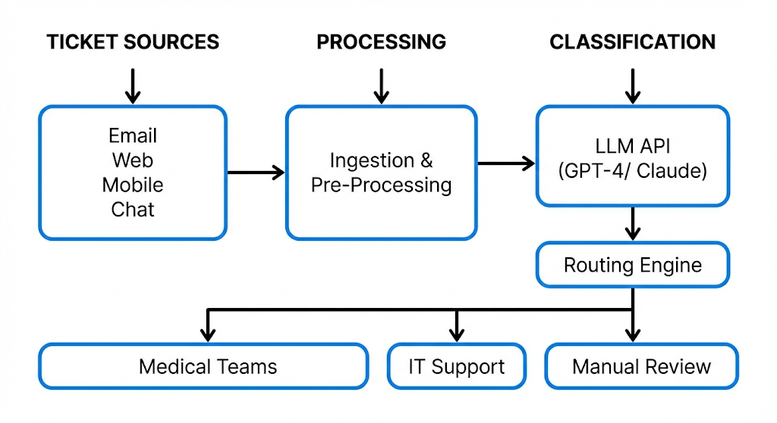
System Components:
- Ticket Ingestion Layer: API, validation, duplicate detection, metadata extraction
- Pre-Processing Layer: Text cleaning, normalization, PII redaction
- LLM Classification Engine: Zero/few-shot classification, confidence scoring
- Routing Decision Engine: Rule-based routing based on classification
- Assignment & Notification: Team assignment, alerts, status updates
- Feedback Loop: Agent feedback, prompt refinement, metrics dashboard

4.2 Data Flow Summary
Step | Action | Output
1. Submission | Employee submits ticket | Ticket ID + metadata
2. Pre-processing | Clean text, validate, redact PII | Normalized text
3. Classification | LLM API call with prompt | Classification + confidence
4. Routing | Apply decision rules | Destination team + priority
5. Assignment | Assign to agent, notify | Updated ticket status
6. Resolution | Agent handles, provides feedback | Classification accuracy log

4.3 Medical Ticket Detection Mechanism
Multi-Layered Detection Approach:
Layer 1 - LLM Classification: Primary zero-shot/few-shot classification with confidence scoring
Layer 2 - Keyword Boosting: For medium-confidence results (0.60-0.80), cross-check with medical keyword dictionary to adjust confidence
Layer 3 - Context Awareness: Consider employee history, temporal patterns, department risk profile
Layer 4 - Confidence-Based Routing:
Confidence Level | Action
≥0.85 (High) | Auto-route, no review needed
0.70-0.84 (Medium) | Auto-route with flag for verification
0.50-0.69 (Low) | Route to manual review queue
<0.50 (Very Low) | Default to NON-HEALTH

4.4 Routing Decision Matrix
Classification | Sub-Category | Destination Team | SLA
HEALTH | Emergency | Emergency Medical / Hospital | 15 min
HEALTH | Mental Health | Mental Health Counselor | 4 hours
HEALTH | Injury/Accident | Occupational Health Nurse | 2 hours
HEALTH | Routine Medical | General Medical Team | 24 hours
HEALTH | Insurance | HR Benefits Team | 24 hours
NON-HEALTH | IT Support | IT Help Desk | 4 hours
NON-HEALTH | HR Admin | HR Department | 24 hours
UNCERTAIN | Low Confidence | Manual Review Queue | 8 hours

4.5 Advantages of Cloud-Based LLM APIs Over Traditional NLP
Aspect | Traditional NLP | Cloud LLM APIs
Development Time | 3-6 months | 1-2 weeks
Labeled Data Required | 5,000-50,000 | 0-50 examples
Annotation Cost | $10,000-$50,000 | $0-$500
Initial Accuracy | 60-70% | 75-92%
Infrastructure Cost | $5,000-$20,000 | Pay-per-use
Maintenance | High (retrain quarterly) | Low (prompt updates)
Scalability | Limited | Unlimited
Adaptation Time | Weeks | Hours
Multilingual | Separate models | Native support
Explainability | Limited | High (reasoning available)

Cost Comparison (Annual):
Cost Category | Traditional | LLM API
Year 1 Total | $105,000 | $17,600
Year 2+ | $55,000/year | $7,600/year
Savings | - | $87,400 Year 1
Key Advantages:
- No training data requirement - Works with zero labeled examples
- Rapid deployment - 2 weeks vs. 4 months
- 70-80% cost reduction - Lower upfront and ongoing costs
- Superior accuracy - 85-92% vs. 60-70%
- Easy adaptation - Update prompts in hours, not weeks
- No infrastructure management - Provider handles scaling
- Built-in multilingual support - Single prompt for 50+ languages

5. Implementation Recommendations

5.1 Technical Stack
- LLM Provider: GPT-4 or Claude 3.5 (primary), Gemini Pro (backup)
- Integration: RESTful API with retry logic
- Caching: Redis for duplicate classifications
- Database: PostgreSQL for metadata and logs
- Monitoring: Datadog/New Relic for latency tracking
- Security: API key rotation, PII redaction

5.2 Performance Metrics
Metric | Target
Classification Accuracy | ≥85%
Precision (Health) | ≥80%
Recall (Health) | ≥85%
API Latency (P95) | <5 seconds
Routing Accuracy | ≥90%

5.3 Continuous Improvement
- Weekly: Analyze misclassifications
- Monthly: Refine prompts based on errors
- Quarterly: Compare with human expert classification
- Annual: Review classification taxonomy

6. Conclusion
Large Language Models offer a compelling solution for classifying health-related tickets without labeled training data. Key benefits include:
- Immediate deployment without data collection delays
- High accuracy (85-92%) competitive with traditional models
- 70-80% cost reduction compared to traditional ML
- Rapid adaptation with simple prompt updates
- Effortless scaling using cloud infrastructure
Key Success Factors:
- Effective prompt engineering with clear class definitions
- Confidence-based routing with human-in-the-loop
- Continuous monitoring and feedback integration
- Multi-provider strategy for reliability
Future Enhancements:
- Fine-tuning specialized models on organizational data
- Semantic search for similar historical tickets
- Predictive urgency classification
- Integration with electronic health records

